Self-Organising Fun: A Force-Directed-Graph in CoffeeScript
- Play with a working demo
- The source code on GitHub
I wanted to learn CoffeeScript so I choose to investigate Force Directed Graphs as a fun learning project. They appeal not just because self-organisation is intrinsically fascinating but also because the project would give me the opportunity to compose a whole set of exciting web technologies including CoffeeScript, JQuery, HTML5 and Processing.js.
For more information on Force Directed Graphs please see the Definitions and Discussion sections below.
Technology Stack
- Visual Studio 2012 Express
- Jurassic Coffee
- CoffeeScript
- JQuery
- Processing.js
- Bootstrap
- Html5
The Demo
The demo allows you play with Force Directed Graphs of various sorts. Here is a quick rundown of each option.
The first dropdown determines the number of copies of each graph to generate.
The second dropdown determines the type of graph to be generated. Each graph type differs in the number of nodes, the interconnections between the nodes and the node mass and so each graph self-organises into a different pattern however the physical constants that determine magnetic repulsion and spring strength remain the same for all.
The third dropdown allows you to change the behaviour of a node as it encounters the edge of the drawing area.

The Noise dropdown allows you to introduce random noise into the mix. It is known that Force Directed Graphs will often beach themselves on the shores of suboptimal solutions. These locally optimal solutions trap the pattern close to but not quite at the absolute optimal solutions. Randomness can help fix that by jiggling the system to overcome the local optima and allow the system to keep falling towards perfection.
The Springs checkbox toggles the springs on and off. How do the nodes act when they are unfettered?
The Magnets checkbox toggles the magnetic repulsor fields on and off.
The Help link brings you back to this page.
Definitions
- Graph
A picture of an interconnected set of items where each item is represented by a node and each connection by a link.
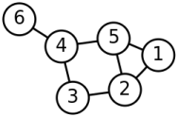
- Force Directed Graph
A graph that self-organises until its nodes are as far apart as possible and the links do not cross. The nodes repulse one another whereas the links act like springs.
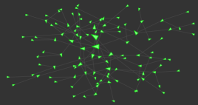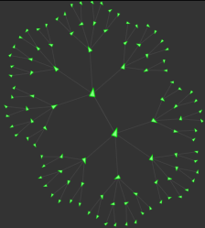

Discussion – What is a Force Directed Graph?
Imagine a single tennis ball connected to ten otherwise identical balls by equal lengths of string. How to disentangle this?
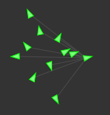
You could take the brute force approach and sit cross-legged unpicking the knots and arranging the balls. Or you could just let the whole thing self-organise until no balls touch and no strings cross.
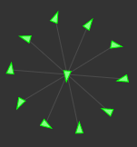
You may think that a system of tennis balls and string cannot self-organise but that is not true. This system, like all physical systems, will organise itself until it reaches a low-energy state. It will stop self-organising just as soon as no energy-lowering moves remain, in other words, when every remaining move implies a rise in the energy state of the system.
The problem: For tennis balls and string this final state is vastly more likely to be a tangled mess rather than a pleasing, symmetrical pattern. We could re-engineer the system using exotic materials but doing this in the real world would be impractical.
The trick is to simulate a node-and-link system (a graph) so that its lowest energy state happens to resemble the pattern you want. Then the system will then self-organise as before only this time it will self-organise to the desired pattern.
As a ball rolls downhill so the system will automatically untangle and organise. It’s not magic, it just looks that way because real systems overwhelmingly tend not be ordered at low energy states. Disordered states so vastly outnumber ordered states that our expectations assume that a system’s low energy state will be disordered, and this is usually correct.
But we don’t want to just define a low energy state and have the system go there. That’s no fun. Instead we want to simulate a pseudo-real physical system, albeit one with impractical properties. The complex behaviour should then just spontaneously emerge from the nature of system itself rather than then from any top-down pre-definition.
To achieve this we must replace the tennis balls with imaginary repulsor ‘magnets’. The closer these magnets get to each other the greater the repulsive force they feel. Now replace the link-strings with springs. The more each spring is stretched the greater the pull on the balls at either end. Now tweak the strength of the repulsor fields and the attractor-springs until a nice, critical balance is reached.
A system like this will seek a low energy state just like any real physical system would. As you watch the heaped mess you will see it writhe and twist, the balls repelling and the springs attracting, untangling and ordering until it finally assumes a close approximation to the low-energy, ordered pattern we seek. No external effort is required; the system is powered by virtual kinetic energy harvested from virtual potential energy as the system spontaneously falls down an imaginary energy gradient.
A Force Directed Graph is therefore a computer representation of such an edge-case physical system. It models repulsive nodes and springy edges with the final shape of the optimally ordered pattern being determined by the graph’s interconnections, the mass of the nodes and the precise balance of the opposing forces of attraction and repulsion.

